

|  |
| --- |
| Presentation  ttttttttttT |
| Team member :-  Noura Hamza Abdel_Rahman  Nour El_Hoda Mostafa Mohamed  Hagar Hussien Abdel_Aziz  Nour El_Hoda Ahmed Mohamed  Section : 8  Team Number :80 |
|  |



# Description..

**The project about An Application That enable The Client to park  
their cars easily in The Shopping mall.

**The Application will be related with A sensor that sends notifications  
to tell the users if the place is empty or busy.

**If the pace is busy the sensor sends Green mark on the place .  
And if the place is busy it will send A red mark on the place.

**This Application will Optimal Use of Areas.

**And Reducing the time and effort to park a car.

**Protecting customer Vehicles from Damage.

**This application only runs in shooping malls.

**It's only run out on iphone and Android.

Risk

1. Possible senor allergy to any object other than a car so we can make the sensur so that it only induces metals Weight of at least 10 kg.
2. There are some people who can't read and write, so we have to make the application respond to the voice commands of the corner service.
3. There are some people who are not subscribed to this application. The solution is to put a device outside the garage gate that determines the empty places and their area for people.

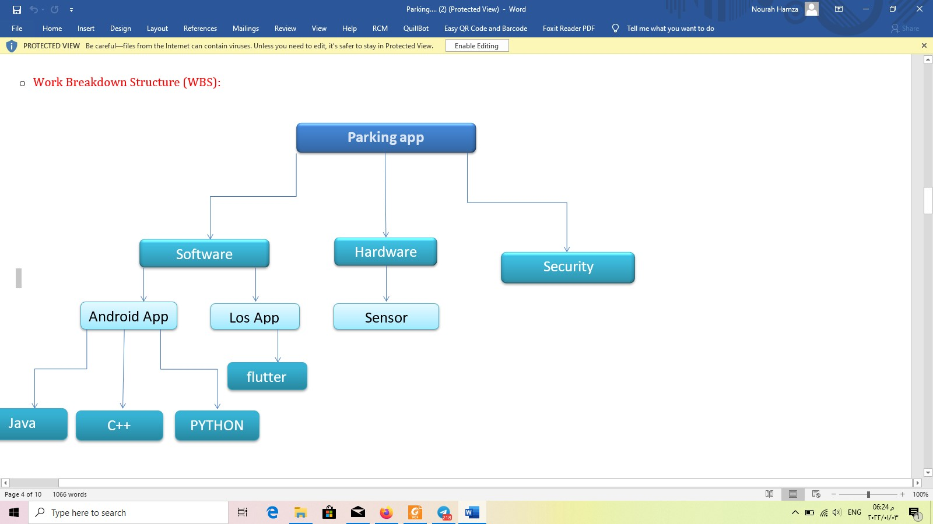Resources

1. Team members.
2. Appstore (iPhone,Android).
3. Sensor.

Resource constrain.

1. It should not take more than 4 months.
2. Project Cost Should not be More than 400000$.

Task allocation

|  |  |  |  |  |
| --- | --- | --- | --- | --- |
| Task  task Name | Noor EL_Hoda Ahmmed | Noora Hamza | Noor EL_Hoda Moustafa | Hager |
| Define requirements |  | S |  | R |
| Distribute responsibilities |  |  | R | S |
| Assign tests | R | S |  |  |
| Building software | S |  | R | S |
| Designing interface | R | S | S |  |
| Testing | S | R | S | S |
| Launching and marketing |  | S | S | R |

R responsibilities

S Support

* + **Network:**

|  |  |  |  |
| --- | --- | --- | --- |
| activity | Description | Processor | Duraction |
| A | Define requirements | None | 3 |
| B | Distribute responsibilities | A | 2 |
| C | Assign tests | A | 1 |
| D | Building software | B | 4 |
| E | Designing interface | C | 4 |
| F | Testing | D | 2 |
| G | Launching and marketing | E,F | 5 |

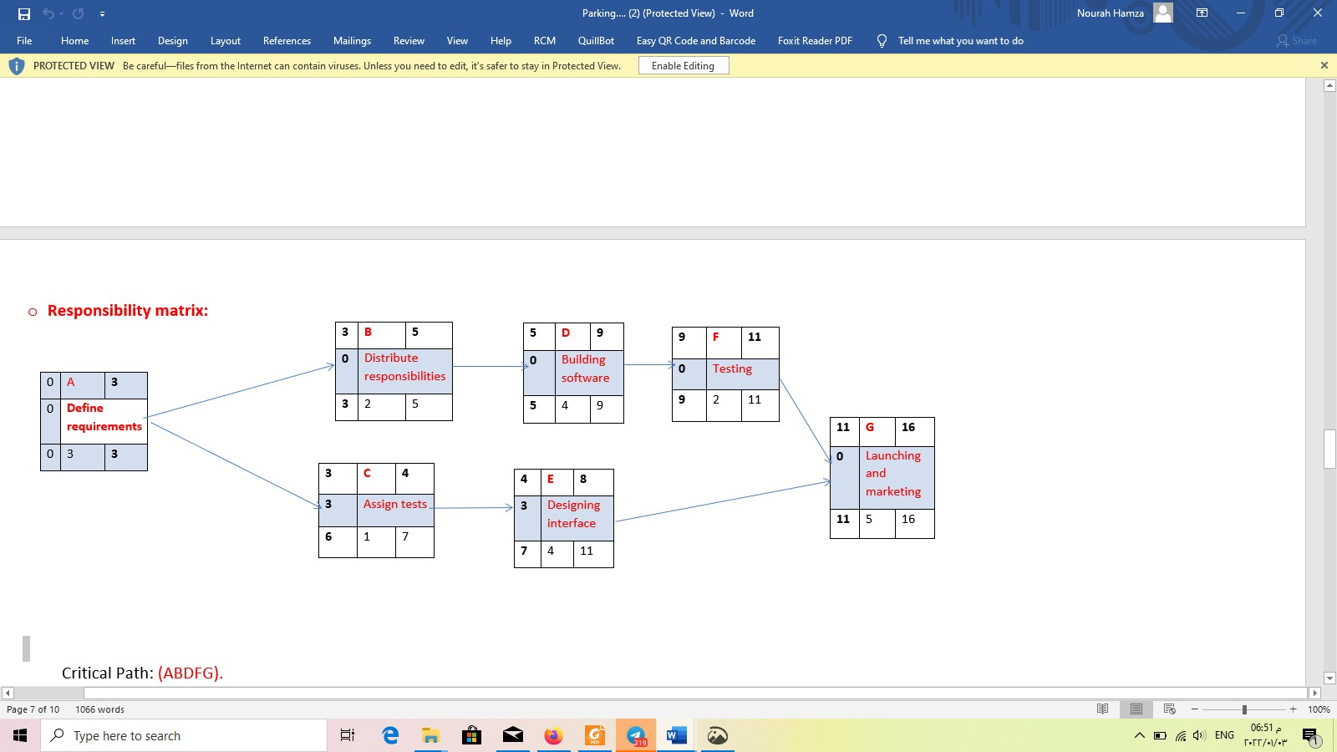

Critical Path: (ABDFG).

|  |  |  |  |  |  |  |  |  |  |  |  |  |  |  |  |  |  |  |  |  |  |
| --- | --- | --- | --- | --- | --- | --- | --- | --- | --- | --- | --- | --- | --- | --- | --- | --- | --- | --- | --- | --- | --- |
| ID | Res | Dur | Es | Lf | Sl | 1 | 2 | 3 | 4 | 5 | 6 | 7 | 8 | 9 | 10 | 11 | 12 | 13 | 14 | 15 | 16 |
| A | 2 | 3 | 0 | 3 | 0 | 2 | 2 | 2 |  |  |  |  |  |  |  |  |  |  |  |  |  |
| B | 2 | 2 | 3 | 5 | 0 |  |  |  | 2 | 2 |  |  |  |  |  |  |  |  |  |  |  |
| C | 2 | 1 | 3 | 7 | 3 |  |  |  | 2 | - | - | - |  |  |  |  |  |  |  |  |  |
| D | 3 | 4 | 5 | 9 | 0 |  |  |  |  |  | 3 | 3 | 3 | 3 |  |  |  |  |  |  |  |
| E | 3 | 4 | 4 | 11 | 3 |  |  |  |  | 3 | 3 | 3 | 3 | - | - | - |  |  |  |  |  |
| F | 4 | 2 | 9 | 11 | 0 |  |  |  |  |  |  |  |  |  | 4 | 4 |  |  |  |  |  |
| G | 3 | 5 | 11 | 16 | 0 |  |  |  |  |  |  |  |  |  |  |  | 3 | 3 | 3 | 3 | 3 |
| Total resource | | | | | | 2 | 2 | 2 | 4 | 5 | 6 | 6 | 6 | 3 | 4 | 4 | 3 | 3 | 3 | 3 | 3 |
| Resource available | | | | | | 6 | 6 | 6 | 6 | 6 | 6 | 6 | 6 | 6 | 6 | 6 | 6 | 6 | 6 | 6 | 6 |

